**Ideation Phase**

**Define the Problem Statements**

|  |  |
| --- | --- |
| Date | 25 June 2024 |
| Team ID | SWTID1719938064 |
| Project Name | ShopEZ: E-Commerce Application |
| Maximum Marks | 3 Marks |

**Customer Problem Statement:**

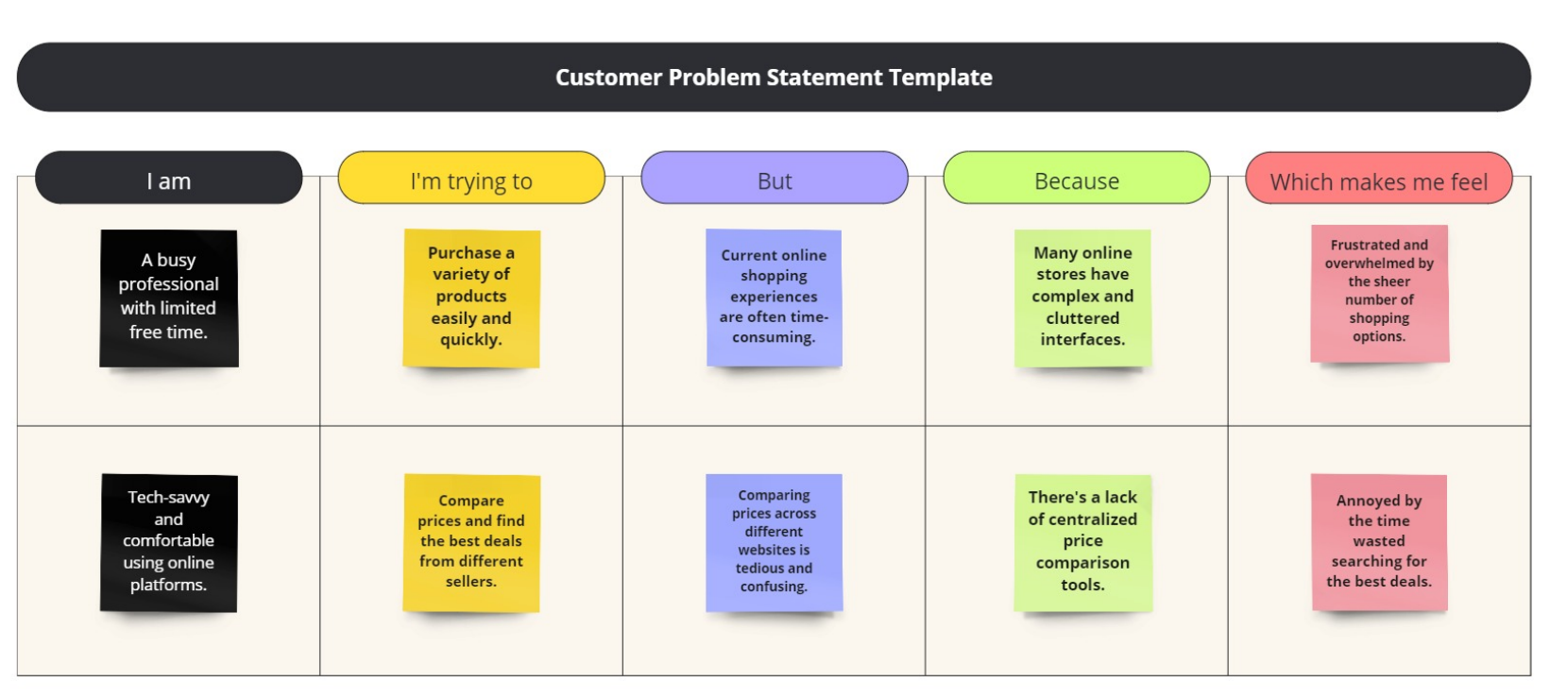

|  |  |  |  |  |  |
| --- | --- | --- | --- | --- | --- |
| **Problem Statement (PS)** | **I am (Customer)** | **I’m trying to** | **But** | **Because** | **Which makes me feel** |
| PS-1 | A busy professional with limited free time. | Purchase a variety of products easily and quickly. | Current online shopping experiences are often time consuming. | Many online stores have complex and cluttered interfaces. | Frustrated and overwhelmed by the sheer number of shopping options. |
| PS-2 | Tech-savvy and comfortable using online platforms. | Compare prices and find the best deals from different sellers. | Compare prices across different websites is tedious and confusing. | There’s a lack of centralised price comparison tools. | Annoyed by the time wasted searching for the best deals. |